**Chapter 5: RELATIONAL DATABASE DESIGN**

**Domain And Data Dependency**

* **Domain:** Unique set of values (like string can have string values).
* **Dependencies:** Relation between 2 or more attributes.
* **Prime attribute:** Dependent on candidate key.
* **Non-prime attribute:** *now you know*
* **Super key:** Group of keys identifying rows in table.

**Types Of Dependencies**

* Functional dependency
* Transitive dependency: **If A -> B, B -> C then indirectly A -> C.**
* Partial dependency

**Functional Dependency**

* Set of constraints between two attributes.
* Let X and Y be **subsets** of attributes.
* For a tuple, if values of attributes under X determine value of attributes under Y in some way.
* Then Y is functionally dependent on X, or X functionally determines Y.
* **X -> Y** (X at left is determinant, Y on right is dependent).

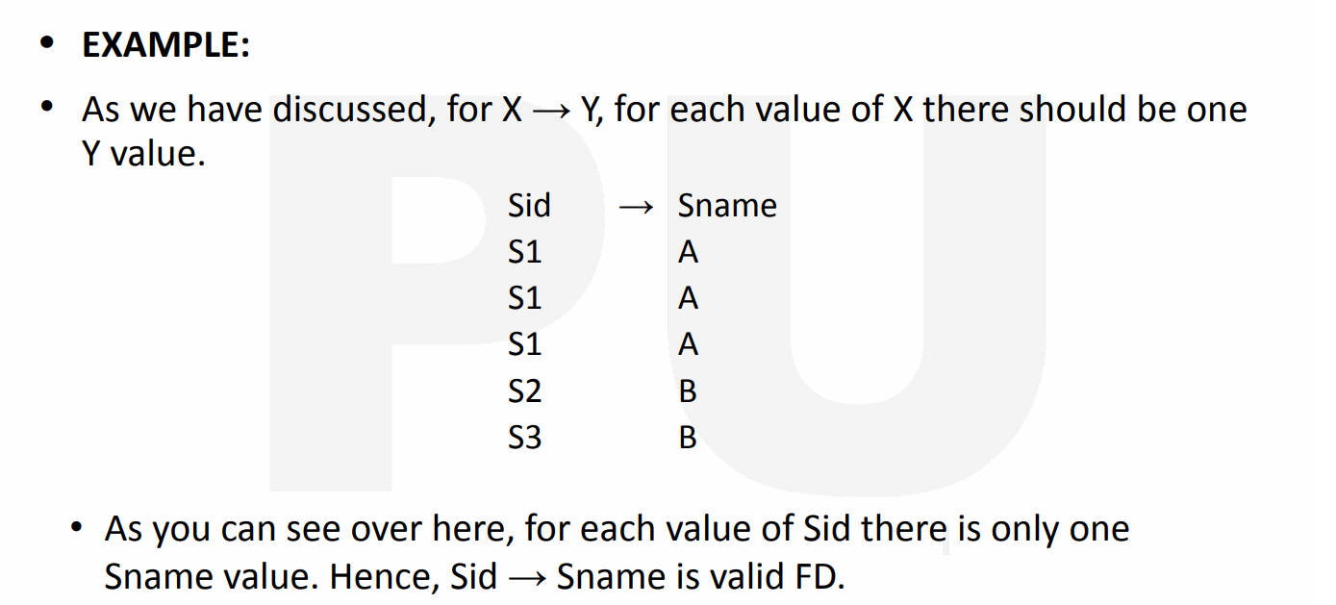

* For each **Sid**, there exists a unique **Sname** (**many to one** relation).

**Normalization**

* Systematic decomposition of tables.
* Process of reducing redundancy of data.
* Improves data integrity.

**Advantages of Normalization**

* Eliminates duplicate data.
* Makes transaction faster.

**Different Anomalies**

* **Anomalies:** Problem that raises during certain operation.
* **Types of anomalies:-**
  + Data anomaly
  + Updation anomaly
  + Deletion anomaly

**Types of Normal Form**

* 1st normal form (1NF)
* 2nd normal form (2NF)
* 3rd normal form (3NF)
* Boyce Codd normal form (BCNF)

**1st Normal Form**

* Removes **composite** and **multi-valued** attribute cells.
* Creates separate table for related data.
* Identifies separate data by **primary keys**.

**2nd Normal Form**

* It has to be in 1st normal form.
* Table **can’t** contain **partial dependency**.
* To solve this, table is split.

**2NF Example**

* Here, **“Office Location”** is partially dependent on **“Employee ID”**.

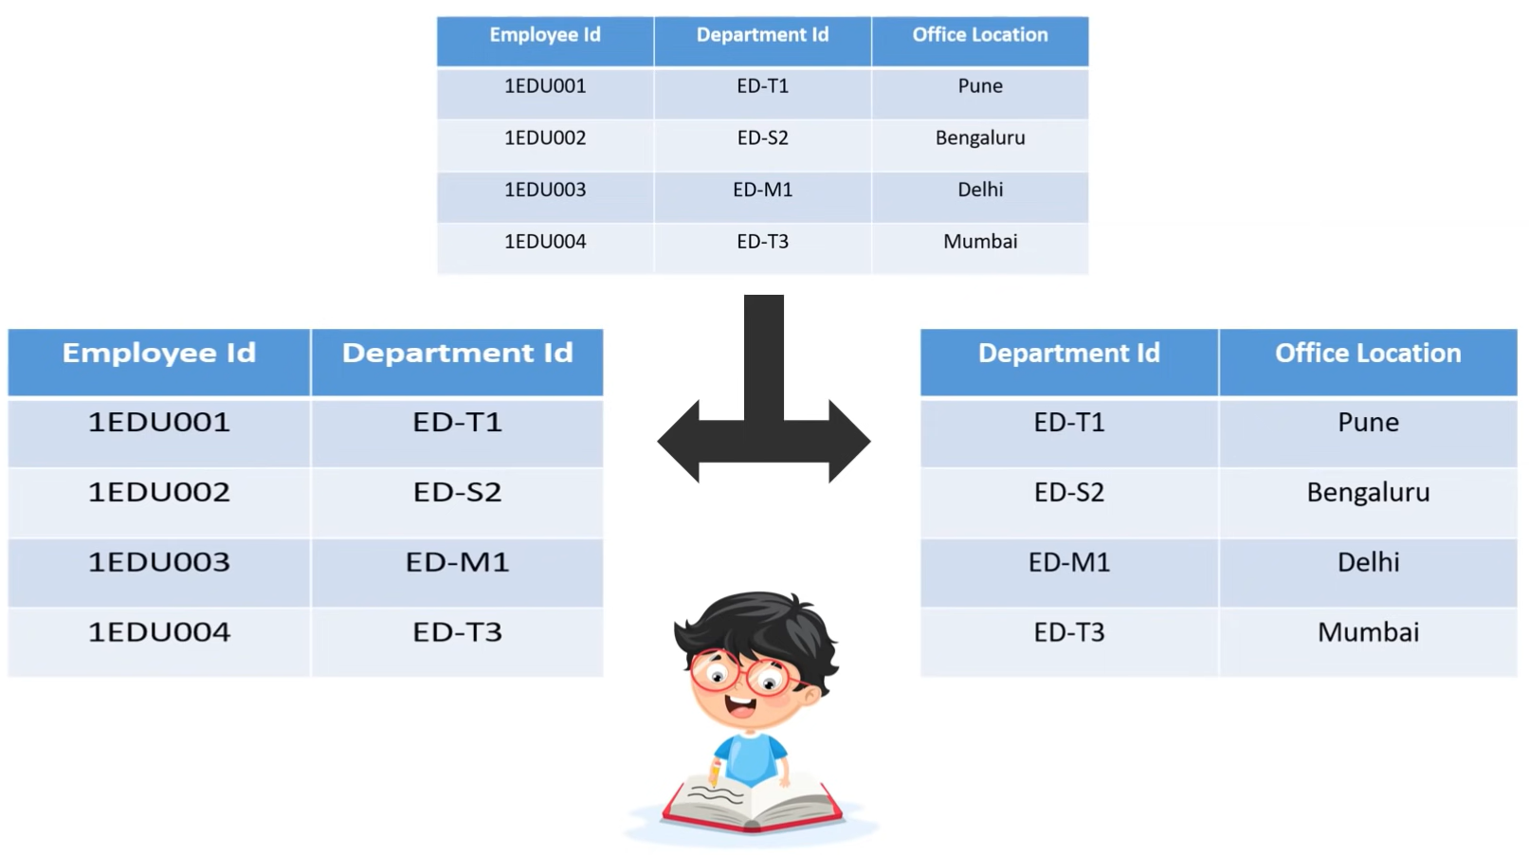

**3rd Normal Form**

* Must be in 2nd normal form.
* **No** transitive dependency for **non-prime** attributes.

**3NF Example**

* Here, **Student Id -> Subject Id** and **Subject Id -> Subject**.

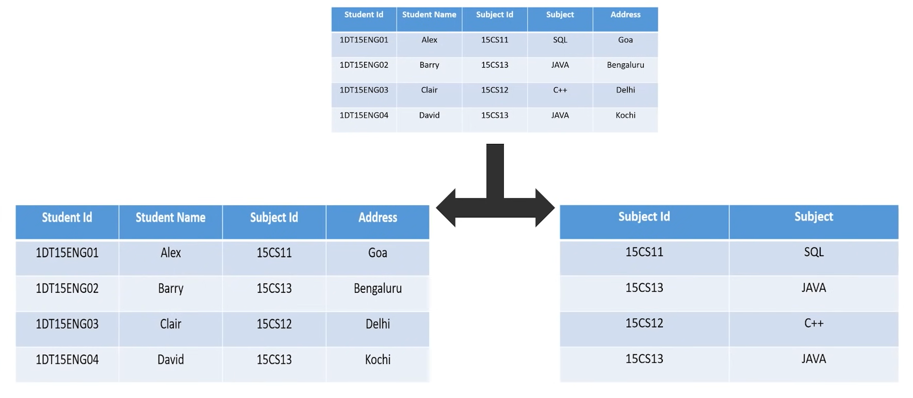

**Boyce Codd Normal Form**

* Must be in 3rd normal form.
* For every functional dependency, **non-dependent** attribute **must be super key** of the table.
* For example, if **A -> B** then **A** must be super key of the table.
* To solve it, a new column is created which is attached to each split part of the given table.